# Folder Comparison Tool User Guide

Folder comparer is a tool that allows the user to view through two different directories within the user’s machine.

## How to use folder comparer:

1. Launch the project and run the application by pressing ‘F5’ or clicking on ‘Debug’ then ‘Start debugging’

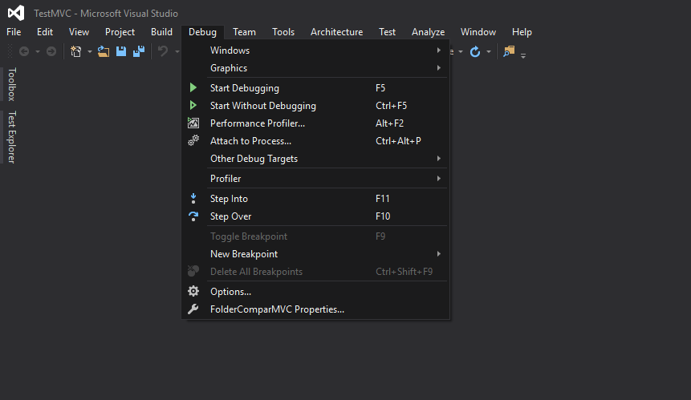

1. Enter the two folder directories in the textbox and press the compare button

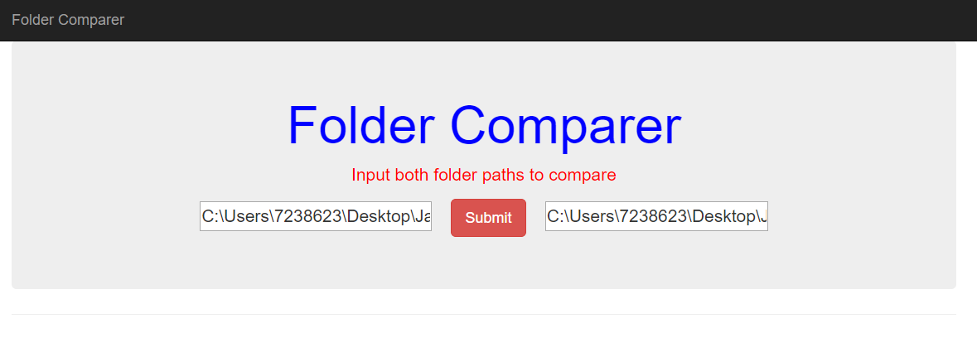

1. View the results

